# UPS Domestic Commercial Ground TT

URL: <https://wwwapps.ups.com/ctc/request?loc=en_US>

## Steps:

1. Go to <https://wwwapps.ups.com/ctc/request?loc=en_US>
2. Enter the “orig_zip” (Column A) into the Ship From ZIP Code field
3. Enter the “dest_zip” (Column B) into the Ship To ZIP Code Field

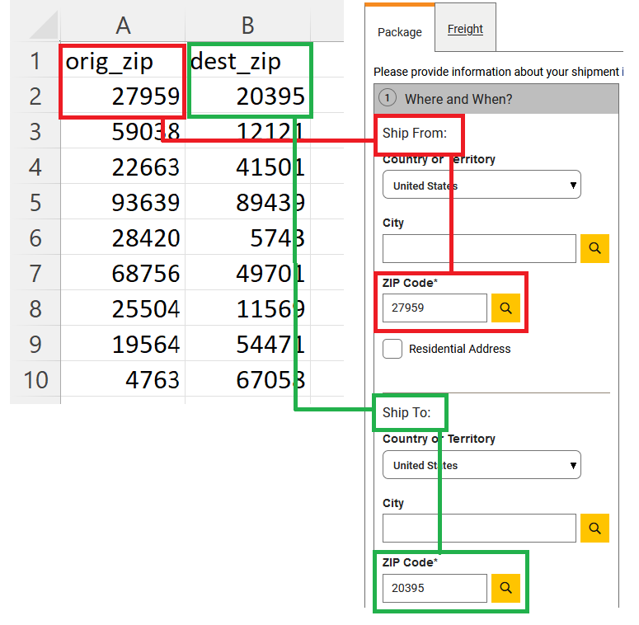

1. Enter the Ship Date in the “When are you shipping” field
   1. For this project, we’ll use two Ship Dates seperately: July 17 (Monday) and July 20 (Thursday)
2. Click the “Update” button

1. Collect the Transit Time result for the “UPS Ground” product only.

## Output Format

|  |  |  |  |
| --- | --- | --- | --- |
| **Orig_Zip** | **Dest_Zip** | **Transit_Days** | **Delivered_By** |
| 27959 | 20395 | 2 | 7/19/2023 |

7.) Sometimes, in the result page, there might be two or more “UPS Ground”. In that case, scrape them as well. You can find a sample ss below. Generally, in those cases, the delivered by: By End of Day Saturday. That is why an additional columns has been put as well to cover those cases in the required_format excel.

